The 2017 SEBAC Agreement defined an increase in employee Pension Deductions of 1.5%. Due to the late implementation of the Pension Deduction Increase, employees had the previous, lower rate in place for the six (biweekly) pay checks of the current fiscal year. For most employees, an extra deduction will be calculated and inserted into their records to make up for the late implementation. However, special handling is needed for employees who retire or terminate from state service before the end of the fiscal year.

NOTE: For any employee who has already retired or terminated between 7/1/17 and 1/31/18 the OSC Retirement Services Division will address the underpayment.

For any upcoming retirees or terminations, agencies are advised to capture the Pension Deductions owed for the first pay cycles of the year as part of the final check process. The pay cycle check dates in question are:

Bi-weekly/Special Bi-weekly: 7/7/17, 7/21/17, 8/4/17, 8/18/17, 9/1/17, 9/15/17

Semi-Monthly: 7/14/17, 7/31/17, 8/15/17, 8/31/17, 9/15/17

Legislators: 7/7/17, 8/4/17, 9/1/17

Step 1:

Depending on the employee’s pay frequency, in order to determine the amount the employee owes, the following data is needed per paycheck for each check date (above). Navigate to Review Paycheck to obtain the ‘RET’ Special Accumulator Amount. (This is the amount is used to calculate Retirement Deductions.)

Navigation:

Payroll for North America/ Payroll Processing USA/ Produce Payroll/ Review Paycheck

The RET Special Accumulator amount of $3,088.21 for check date 7/7/17. Continue for each check date listed previously.

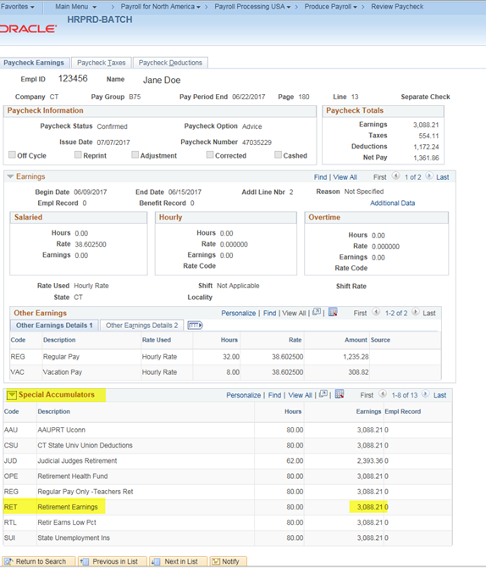

Total the amount for all pay checks.

07/07/17 | $3,088.21
07/21/17 | $3,088.20
08/04/17 | $3,088.20
08/18/17 | $3,088.20
09/01/17 | $3,088.20
09/15/17 | $3,044.09
 | $18,485.10

The result is the Pensionable earning for the employee for the missed pay cycles.

Step 2: Multiply the total for the pay cycles’ Pensionable earnings by 1.5%:

$18,485.10 x 1.5% = $277.28
The result is the Pension deduction underpayment for the employee’s missed pay cycles.

Step 3: Calculate the amount of Catch-Up Deductions Taken

For anyone who retires or terminates on or after 2/1/18 agencies will need to also calculate the total Catch-Up deduction taken.

From Review Paycheck, total the Catch -Up Deduction amounts that have been taken since the February 2nd check date. Deduct that total Catch-Up amount from the total Pensionable deduction underpayment from Step 2 to get the amount of the remaining 1.5% deduction owed. Provide this amount to Active and Pension Payroll Services Division (Step 4).

Step 4: Provide information to OSC Active and Pension Payroll Services Division

Send the following information to OSC Active and Pension Payroll Services Division, at OSC.PAYCORRECTIONS@CT.GOV: the Employee Number, Employee Record, amount, and one of the following catchup Retirement Deductions on the following page.

Example
Employee: Jane Doe
Employee ID: 123456
Amount for Missed Retirement: $277.28
Deduction Code: CDSE2A

Payroll services will process a Deduction Override for the employee’s last check with the information provided.
Catch-Up Deduction Codes for SEBAC 2017

DEDCD(s) | Plan | Description | Catch Up Code
R1HZA4 | SERS | Tier I Plan A Haz Contr | CD1HZA
RS1UCA | SERS | Tier I Plan A UCONN Contr | CD1UCA
RS1PLA | SERS | Tier I Plan A Contr | CD1PLA
R1HZB4 | SERS | Tier I Plan B Haz FICA Contr | CD1HZB
R1SPB4 | SERS | Tier I Plan B Haz NoFICA Contr | CD1SPB
RS1UB1 | SERS | Tier I Plan B UCONN Contr | CD1SUB
RSE1B2 | SERS | Tier I Plan B Contr | CD1SEB
R1HZC4 | SERS | Tier I Plan C Haz Contr | CD1HZC
RS1UCC | SERS | Tier I Plan C UCONN Contr | CD1UCC
RS1PLC | SERS | Tier I Plan C Contr | CD1PLC
RS2AHZ | SERS | Tier IIA Haz Contr | CD2AHZ
RSE2A | SERS | Tier IIA Contr | CD2ASE
RS2SS | SERS | Tier II | CD2SSS
RS2NSS | SERS | Tier II No FICA Contr | CD2NSS
RSE2HZ | SERS | Tier II Haz Contr | CDS2HZ
RS3HZ | SERS | Tier III Haz Contr | CD3SHZ
RSER3 | SERS | Tier III Contr | CD3SER
RSHY3 | SERS | Hybrid Contributions | CD2SHY
RSHY5 | SERS | Hybrid Contributions | CDSHY5

